**Terrestrial Laser Scanning vs. Allometric Models: A Meta-Analysis of Accuracy and Reliability in Forest Biomass Estimation**

Samit Kafle1* and Georgios Arseniou1

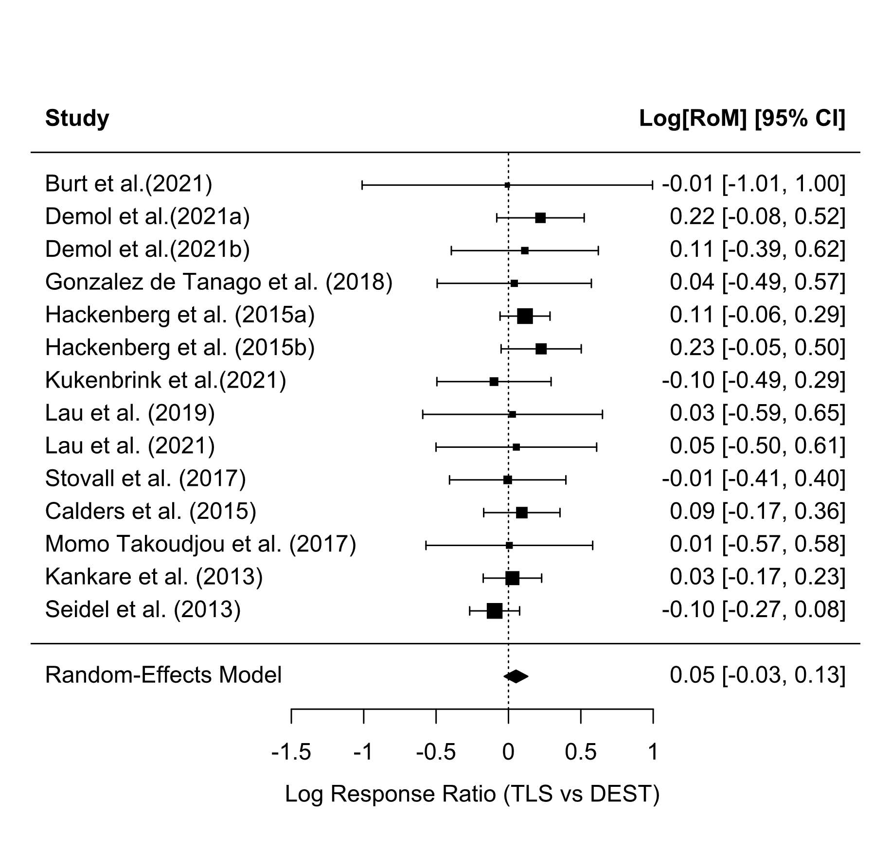

**Figure S1**. Forest plot of log response ratios (and 95% CIs) for TLS-based aboveground biomass estimates versus destructive sampling (true biomass) across the 12 study entries. Points to the right of the zero line indicate TLS overestimation relative to actual biomass, and points to the left indicate underestimation. The pooled estimate (diamond) is very close to zero, reflecting minimal overall bias with TLS.

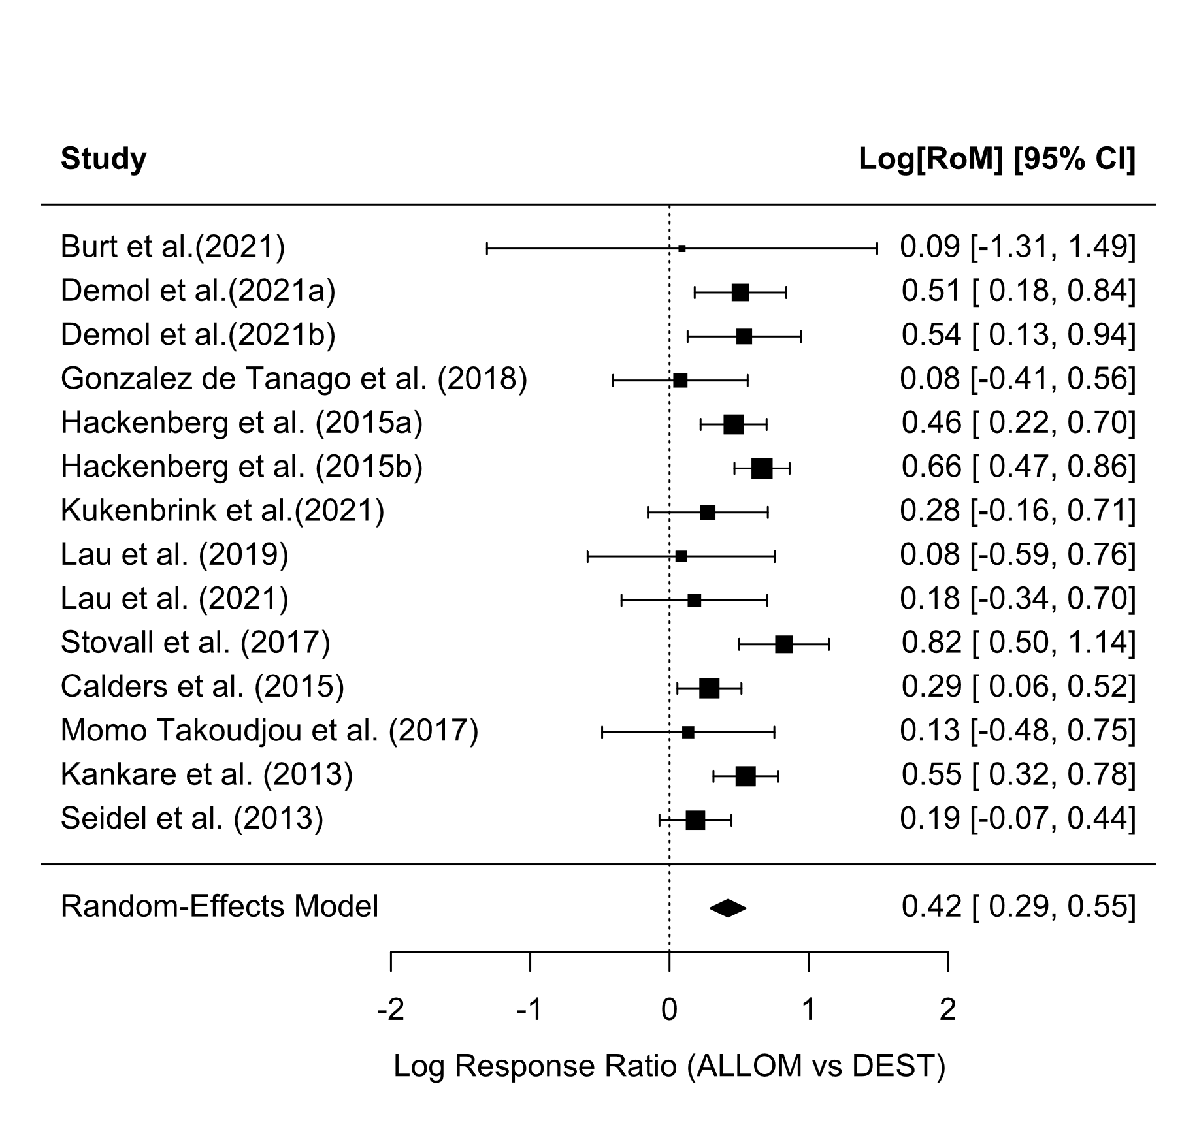

**Figure S2**. Forest plot of log response ratios (and 95% CIs) for allometric equation-based aboveground biomass estimates versus destructive sampling. Most studies show positive lnRR values (to the right of zero), indicating that allometric models often over-predict biomass compared to actual measured values. The pooled effect is significantly positive, reflecting a systematic overestimation by allometric methods on average

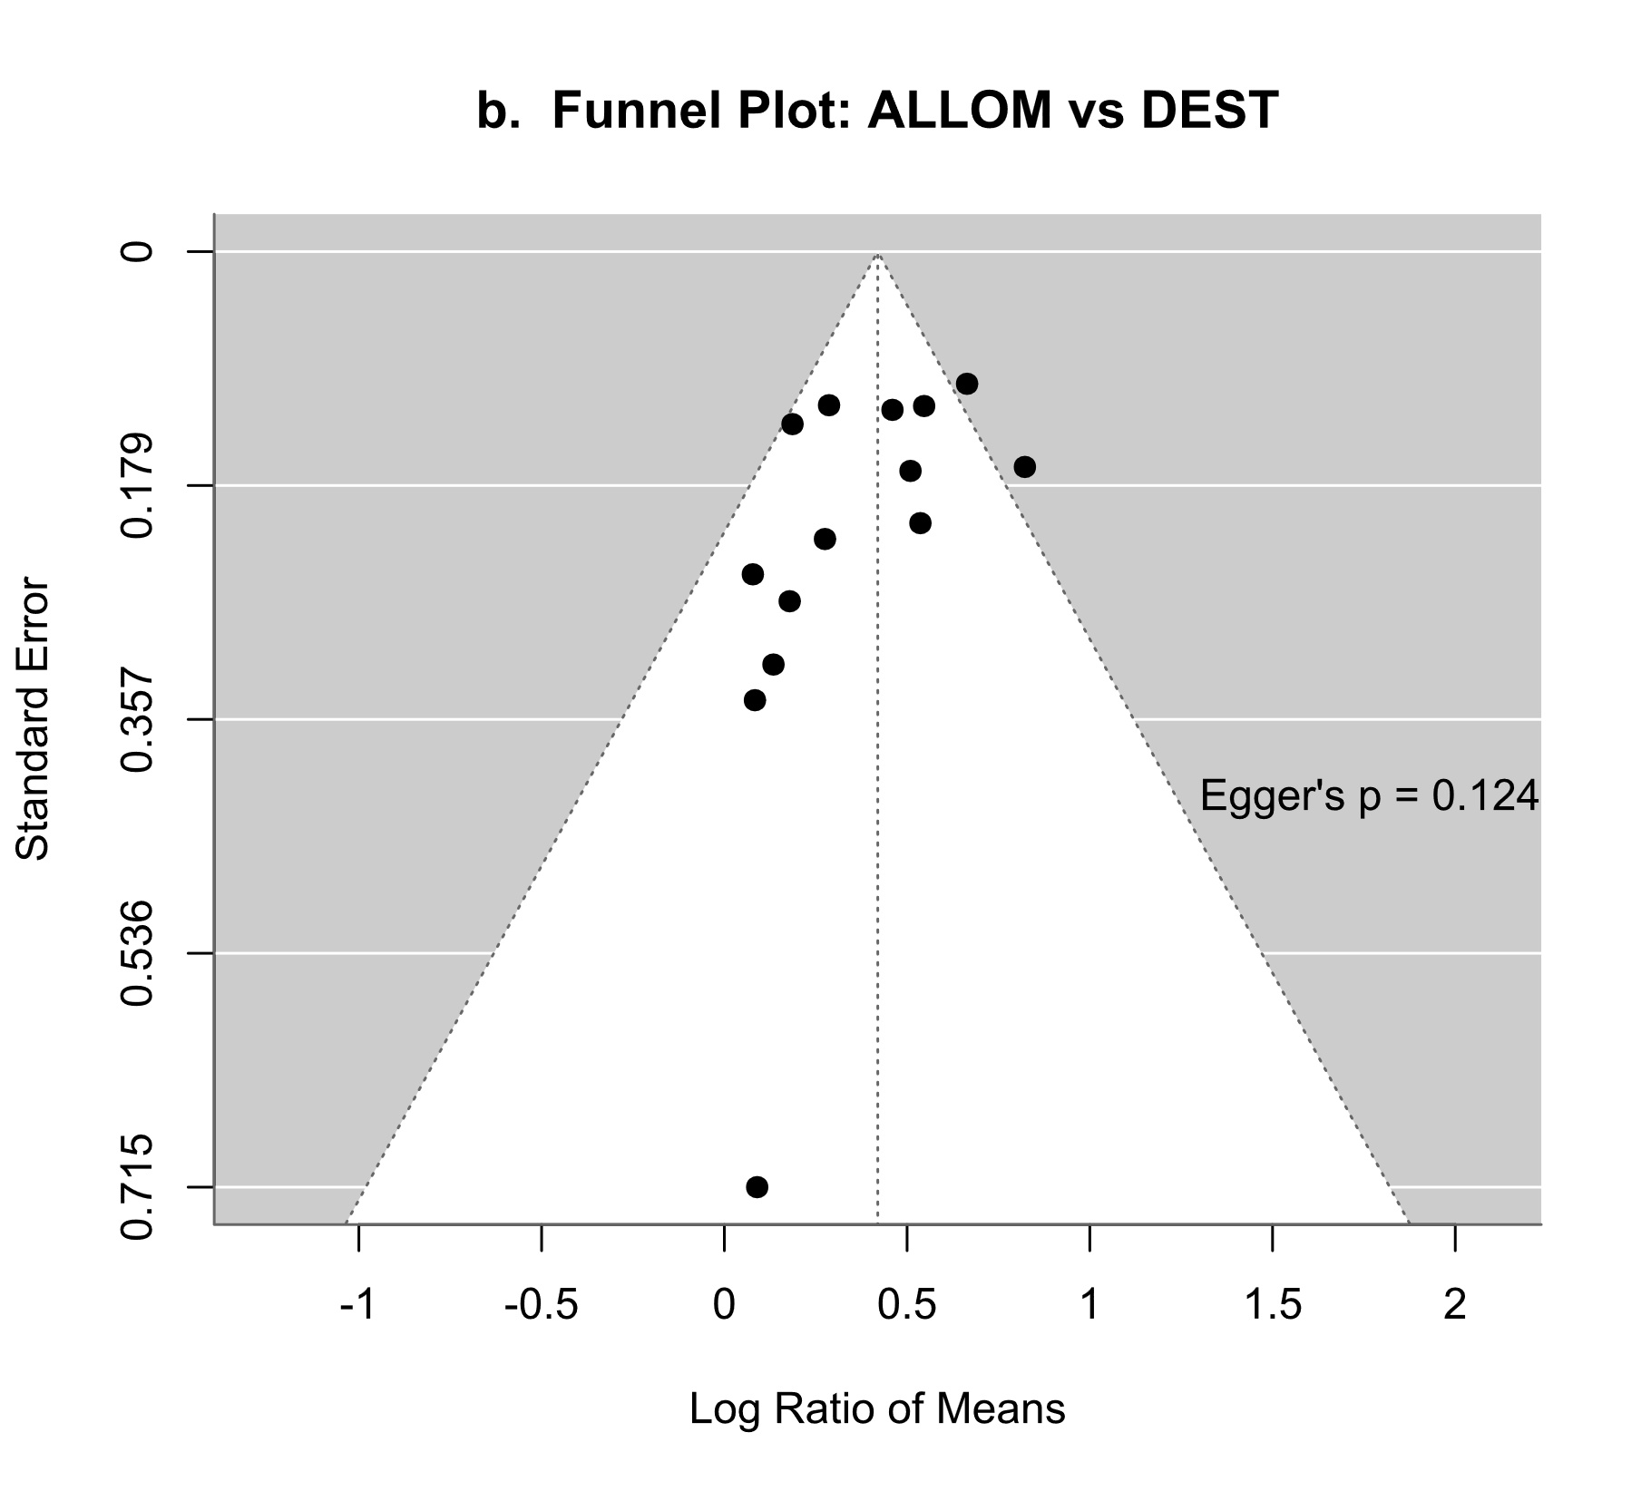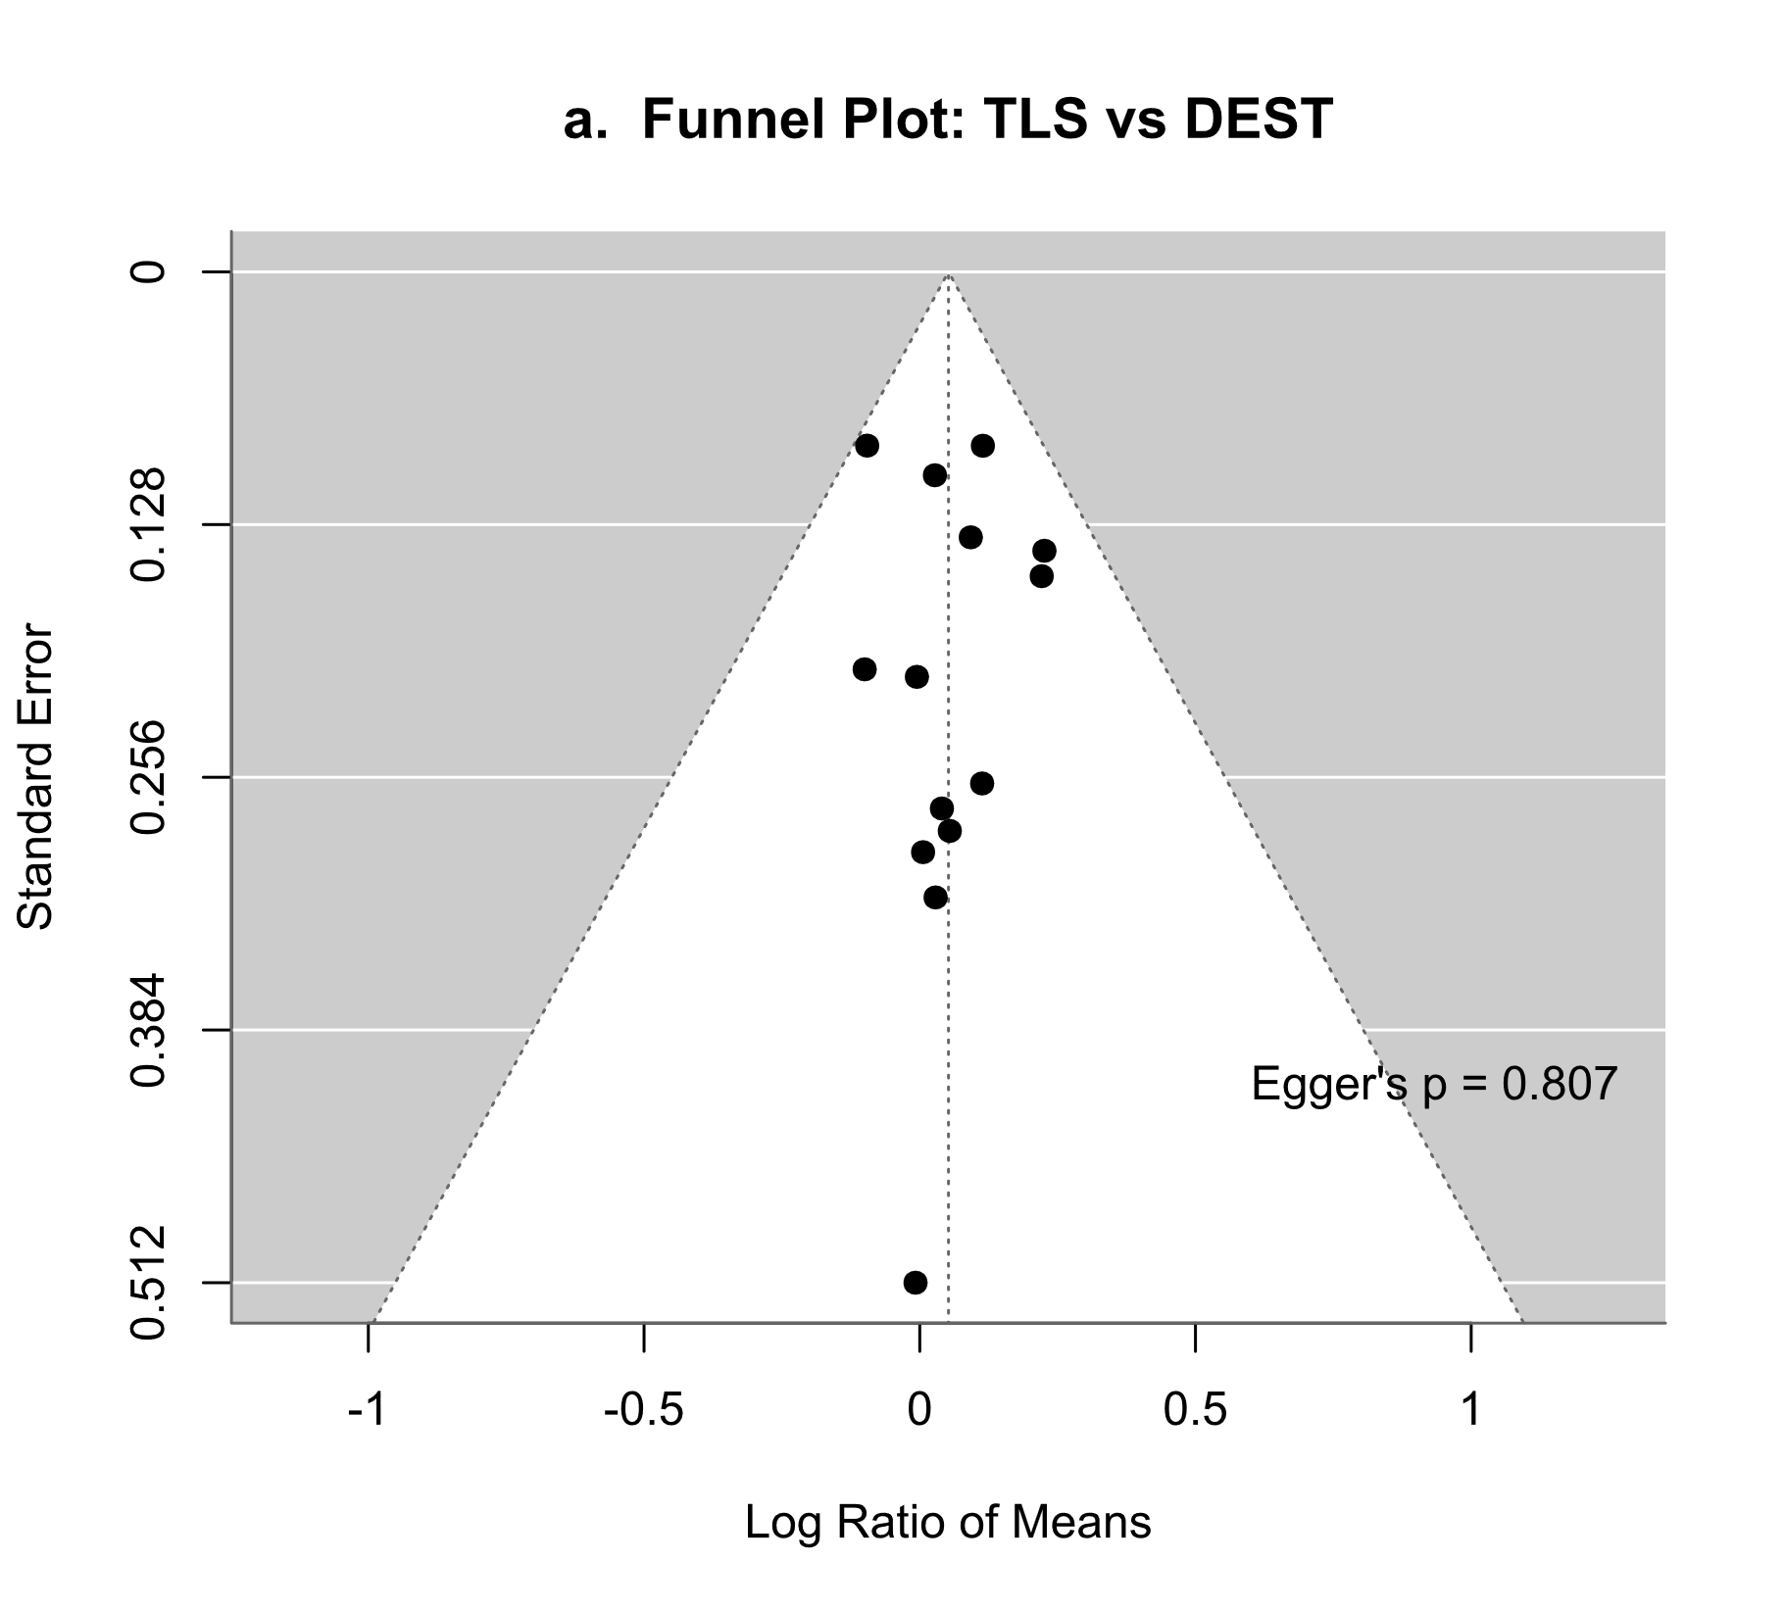

**Figure S3.** Funnel plot assessing potential publication bias in the meta-analysis of a. TLS based biomass estimates b. allometric equation based biomass estimates. Each point represents an individual study’s effect size plotted against its standard error.